### 



System Requirement

Văn Lang Admissions

# Revision Table

|  |  |  |  |
| --- | --- | --- | --- |
| Author | Date | Reason for changes | Version |
| Hien Nguyen  Khoi Nguyen | 27/05/2017 | Content  Fix Template | 1.0 |

Table of Contents

Revision Table 1

1. Website 5

2. CMS Page 13

2.1 Manage Account 13

2.1.1 Login 13

2.1.2 Logout 15

2.1.3 Create Account 16

2.1.4 View List Account 19

2.1.5 Edit Account 20

2.1.6 Search Account 22

2.1.7 View Detail of Account 23

2.1.8 Authorize 24

2.1.9 Deactivate Account 26

2.1.10 Activate Account 27

2.1.11 Forget Password 28

2.2 Manage News 30

2.2.1 View News in CMS page 30

2.2.2 View Draft 31

2.2.3 Create Draft 31

2.2.4 Edit Draft 33

2.2.5 Delete Draft 34

2.2.6 Transfer Draft 36

2.2.7 Approve Draft 37

2.2.8 Post News 38

2.2.9 Deactive News 39

2.2.10 Push News 41

2.2.11 Unpush News 42

2.3 Manage Category 43

2.3.1 View List of Categories in CMS page 43

2.3.2 Create Category 45

2.3.3 Create Categories Level 2 47

2.3.4 Edit Category 49

2.3.5 Delete Category 51

2.4.1 View FAQ 53

2.4.2 Answer Question 53

2.4.3 Approve Question 55

2.5 Manage Banner 56

2.5.1 View Banner in CMS page 56

2.5.2 Create Banner 57

2.5.3 Edit Banner 60

2.5.4 Delete Banner 63

2.5.5 Show Banner 64

2.5.6 Hide Banner 65

2.5.7 Arrange Images 66

# System Requirement

**2 servers:**

**Server 1: Angular2 + Redis + Elasticsearch**

* OS: Window 7 64bit or above
* Ram: 4GB
* Storage: 120GB
* Network: 4MB

**Server 2: Nodejs + MongoDB**

* OS: Window 7 64bit or above
* Ram: 4GB
* Storage: 120GB
* Network: 4MB

**Installation:**

**Node:**

* Access URL: <https://nodejs.org/en/>
* Click download v7.10.0.
* Run node-v7.10.0-x64.msi.

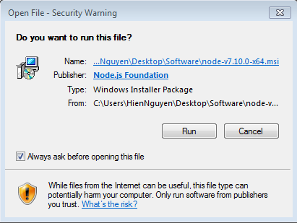

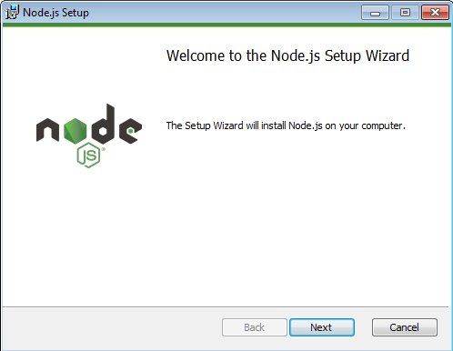

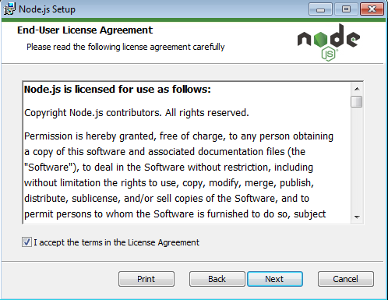

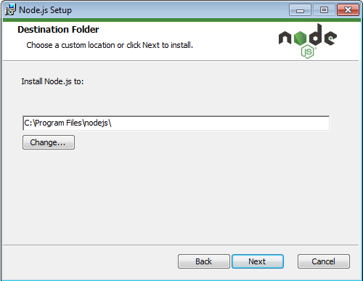

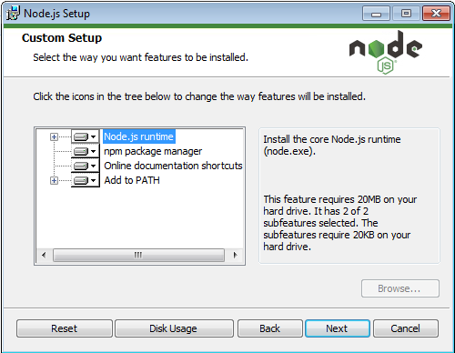

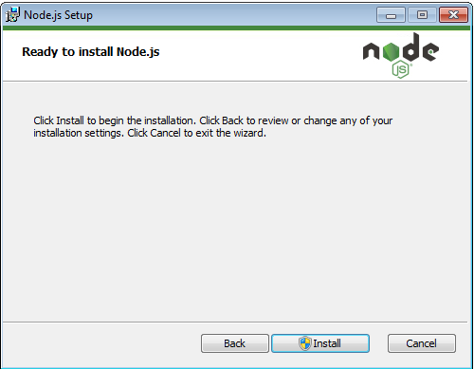

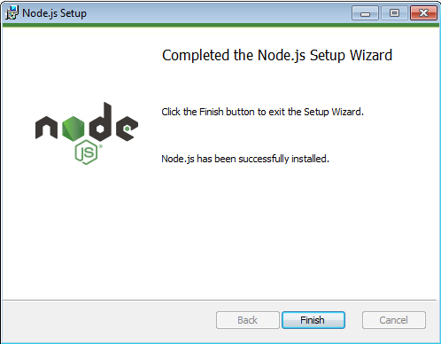

**MongoDB:**

* Access URL: <https://www.mongodb.com/download-center?jmp=nav#community>
* Click download.
* Run mongodb-win32-x86_64-2008plus-ssl-3.4.4-signed.msi

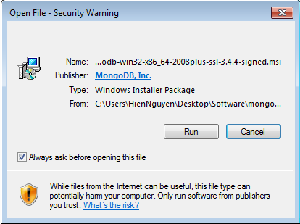

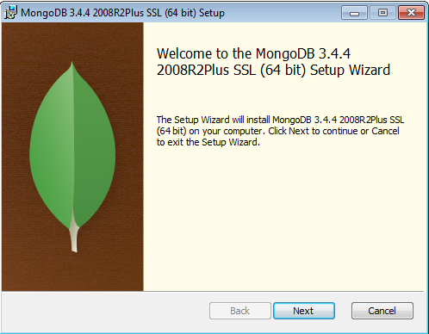

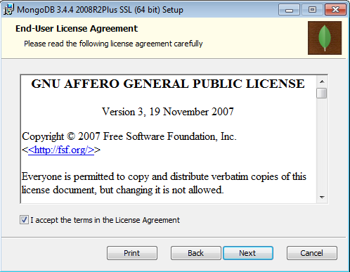

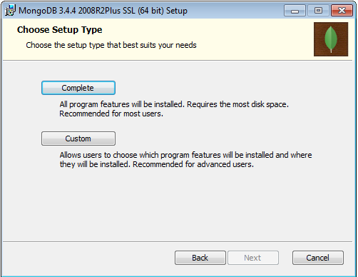

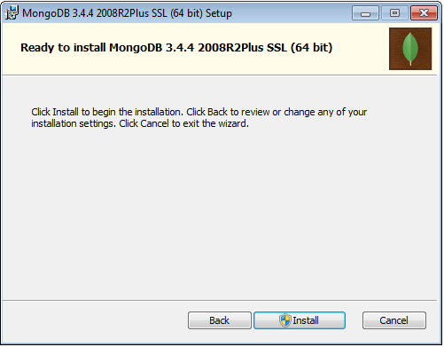

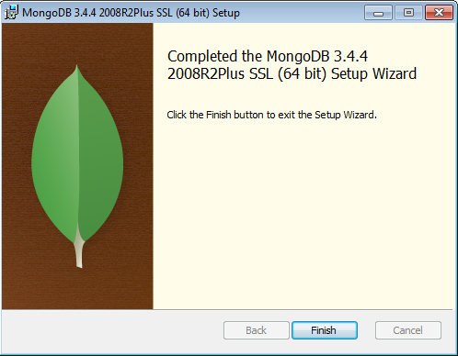

**Redis:**

* Access URL: <https://www.google.com.vn/url?sa=t&rct=j&q=&esrc=s&source=web&cd=1&sqi=2&ved=0ahUKEwjt8NDaqfvTAhWTQpQKHd87AW4QFgggMAA&url=https%3A%2F%2Fgithub.com%2FMSOpenTech%2Fredis%2Freleases%2Fdownload%2Fwin-3.2.100%2FRedis-x64-3.2.100.msi&usg=AFQjCNHq-i0IrCAvdkG6rsAgEZLxZkiRTw&sig2=b74tGA3gO1zedi5rd7jgLQ&cad=rja>
* Run Redis-x64-3.2.100.msi.

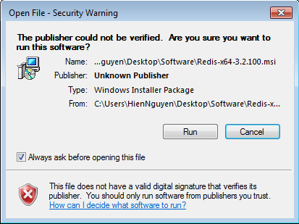

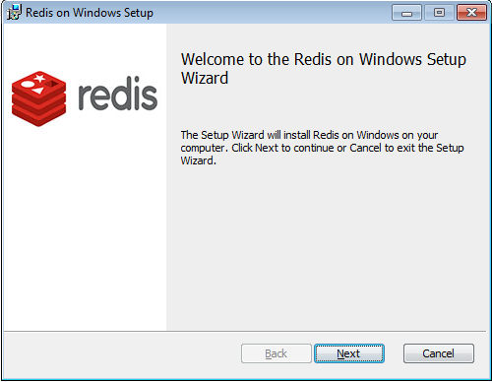

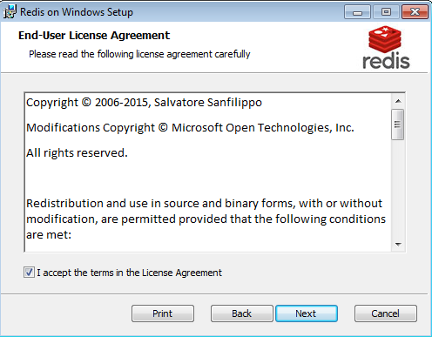

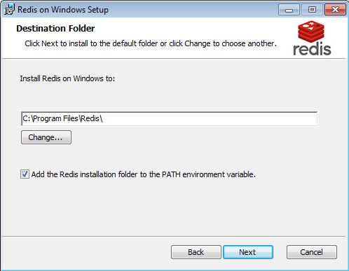

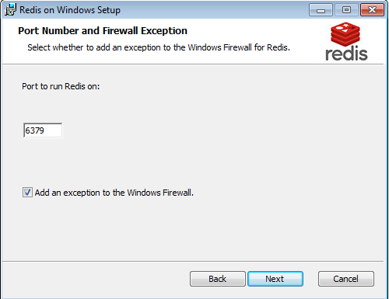

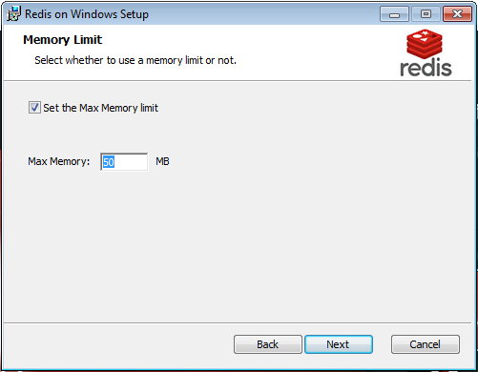

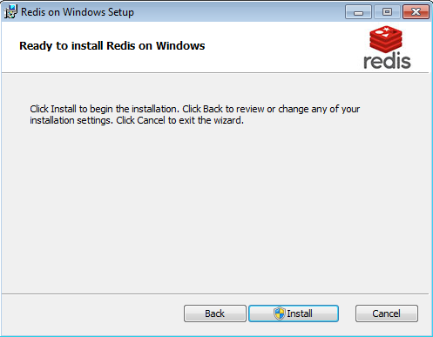

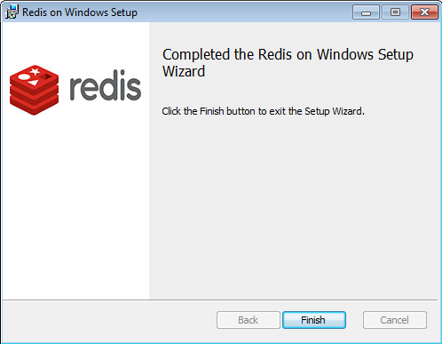

**Elasticsearch:**

* Access URL: <https://www.elastic.co/downloads/elasticsearch>
* Click download ZIP.
* Unzip file elasticsearch-5.3.0.zip.
* Run file elasticsearch.bat in folder bin.

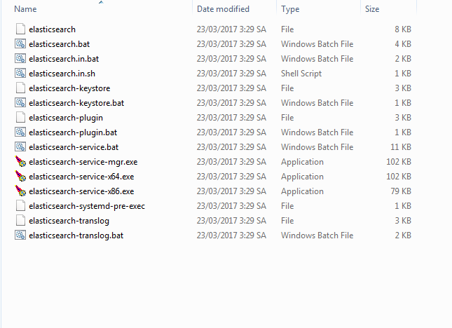

**Run application:**

**Server:**

**Find IP server:**

* Press Window + R.

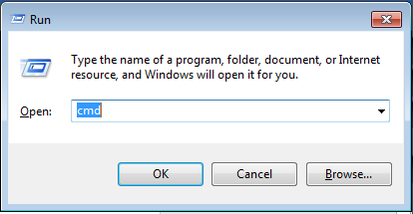

* Type cmd then press enter.

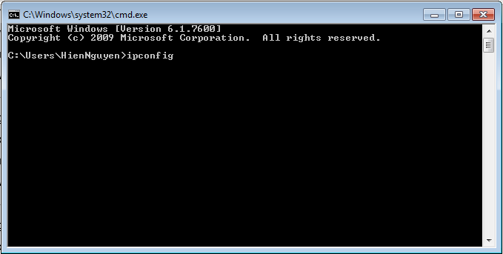

* Type ipconfig then press enter.
* Remember IPv4 Address.

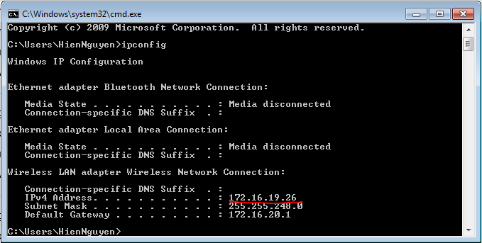

**Set up Server Node:**

* Select folder Server.
* Right click file Config.js.

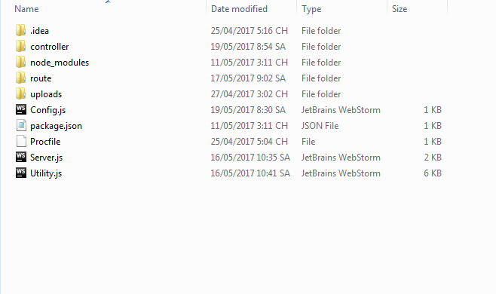

* Choose Open with Notepad.

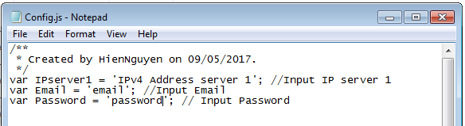

* Replace IPv4 Address server 1 into IPv4 Address in IPserver1 (line 4).
* Add Email and Password in Email and Password (line 5 and line 6).
* Press Ctrl + S.

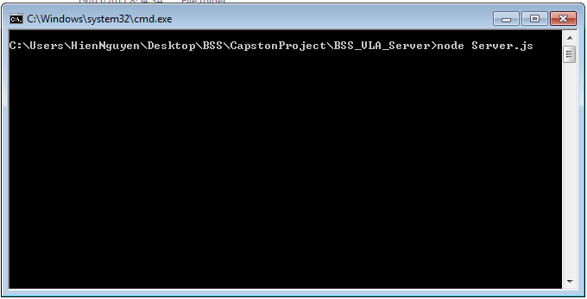

* Then press Ctrl + Shift + Right click white space.
* Choose Open command window here.
* Type node server.js.
* Press enter.

**Front-end:**

* Select folder FrontEnd.
* Press Ctrl + Shift + Right click this folder.
* Choose Open command window here.
* Type npm start.
* Press enter.